Onshore, offshore breeze
1.____________________ breeze

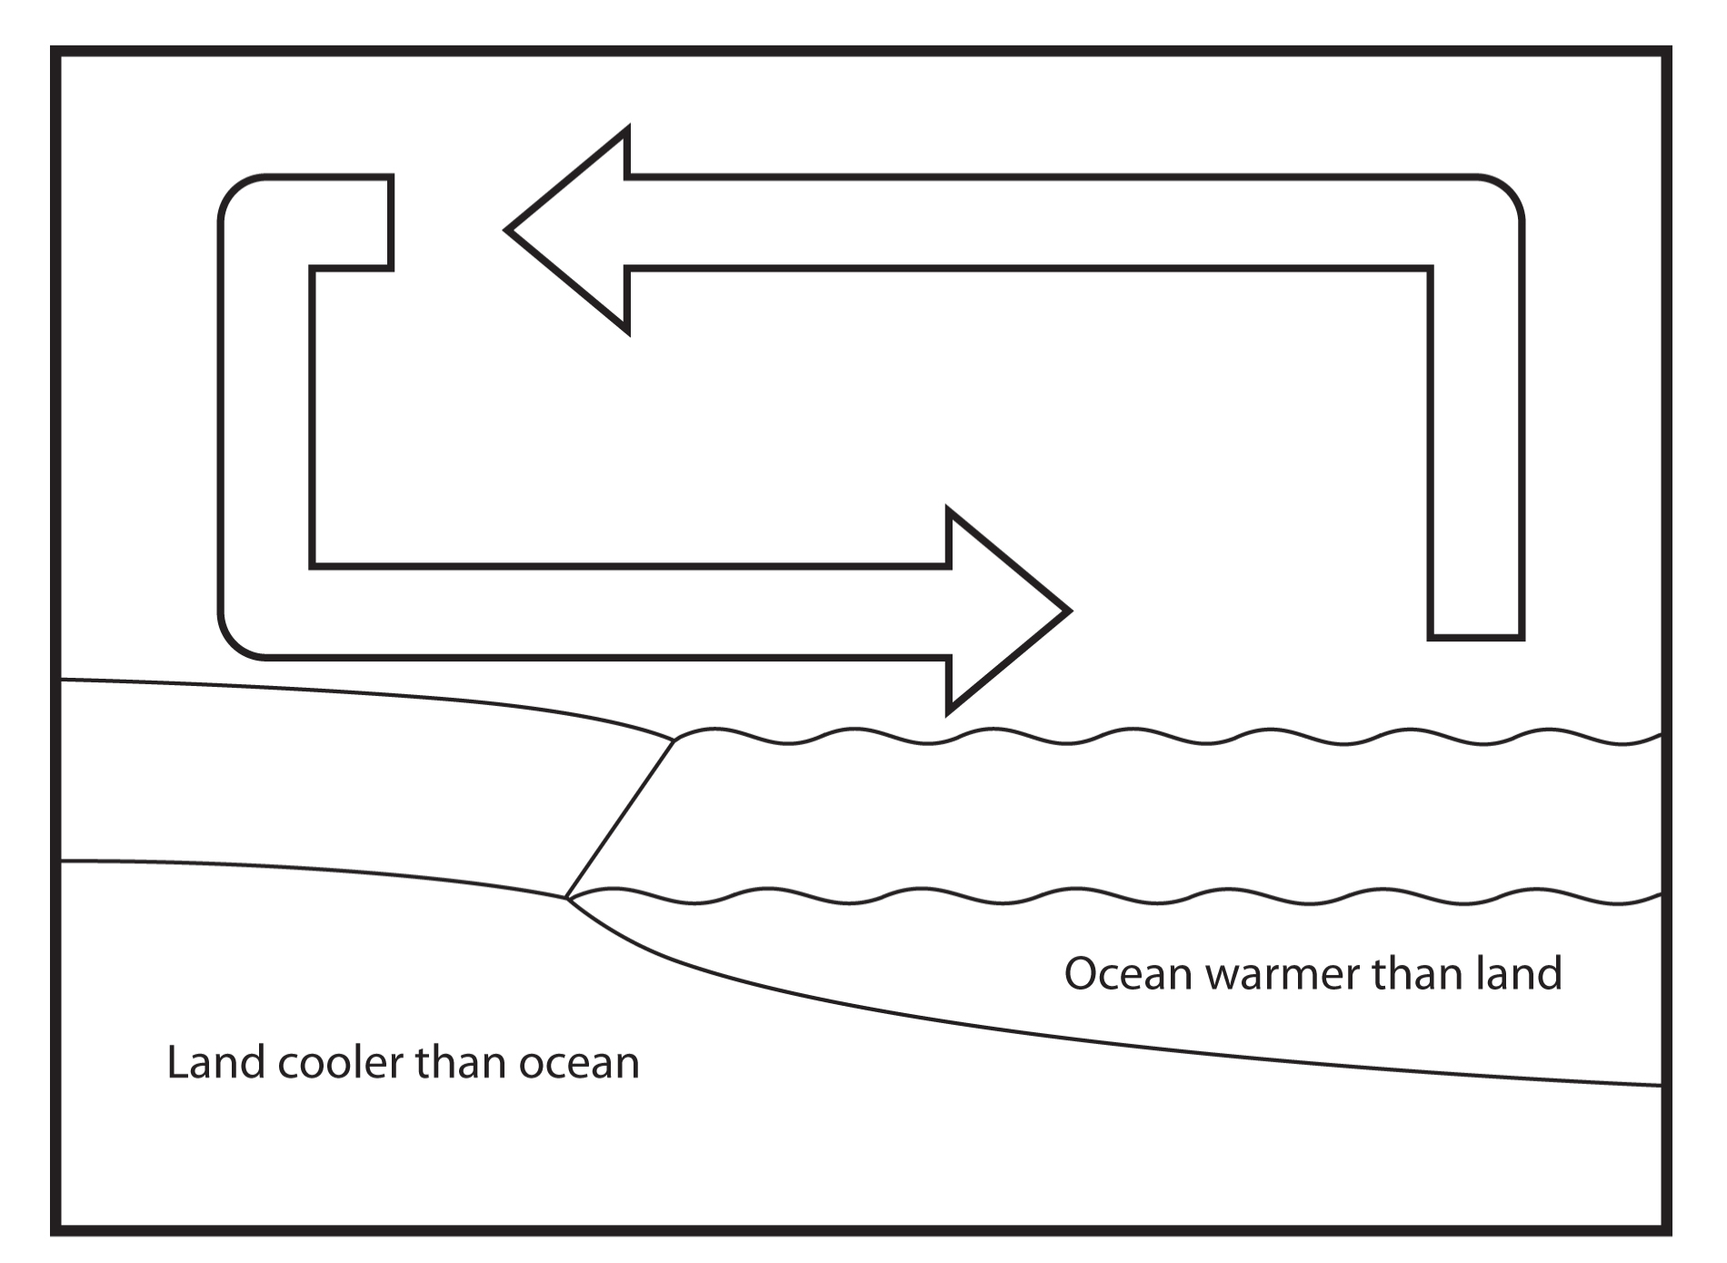

2. ____________________ breeze

